Access control cabinets: full AMETRA capacities for one of the world’s biggest city metro project
J.M

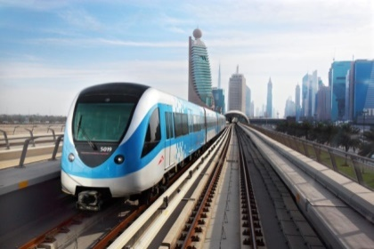
The AMETRA Group was selected by its customer to design and manufacture Metro Cabinets for a 1-billion-resident city. These cabinets will ensure building access control within the metro, and thus lasting security of these facilities, a dimension all the more important as one of the two biggest sports events in the world is fast approaching in this country.
One of the most important public transport projects in the world
This railway project is huge: reaching 100 km/h, the metro will be operating without a driver and will help to decongest the city roads and its suburbs, where over 2.5 million people live, still unaccustomed to using public transport.
The metro will consist of four lines and nearly 40 stations. It will also facilitate the transit of billions of passengers expected for the 2022 World Cup, while ensuring maximum safety for residents, travellers and supporters visiting this country.
For over 30 years, the AMETRA group has been working with different entities of the well-known defence and security company in charge of the metro project. Through its Anjou Electronique company , the AMETRA group has been referenced for a long time as a key partner.
It is during the 2017 Paris Air Show, this aircraft major actor consulted the AMETRA Group for assistance in designing and prototyping access control cabinets for the multi-billion dollar railway project.
Very quickly, AMETRA was entrusted with the production of these cabinets, at the current rate of a dozen per week and for a total of about 200 in the end.
Railway Metro cabinets: expertise provided by the AMETRA Group
Today, the group produces 4 or 5 types of access control cabinets with different levels of security.
AMETRA realized the design, prototyping, industrialization and serial production of all these cabinets; pre integration is done in its Tunisian factory and final integration is realized in France.
That's not all: AMETRA engineers have also designed, developed the software and manufactured specific automatic test benches to validate these cabinets. When integrating the cabinets, the customer will also use these benches.
A demanding project with multiple challenges
Beyond AMETRA’s ability to support their customer from design to serial production, the challenge of a very tight schedule was identified.

After the study, the first prototypes were delivered in October 2017 and the serial production started in January 2018 with a big and fast ramp-up (45 people in production). In just a few months, from design to industrialization and prototyping, the group has increased its production capacity beyond 40 cabinets per month.

This very challenging schedule, often subject to rapid needs of adaptations and modifications to be carried out by the AMETRA team, shows that it is in their DNA to be agile and to demonstrate a great ability to adaptation, while being able to deliver a cabinet that is identical to the previous one.

With this same dynamic agility, the group has also managed its suppliers in a challenging environment for the project supply and delivery part, within one of the largest client projects the AMETRA Group has had the pleasure to take part in.

This project allows the AMETRA Group to be identified as a prime supplier with its client today and to consider new projects in design and prototyping of cabinets’ production in the months and years to come.

To learn more about the AMETRA Group's expertise and achievements, click here.

